Trello  
  
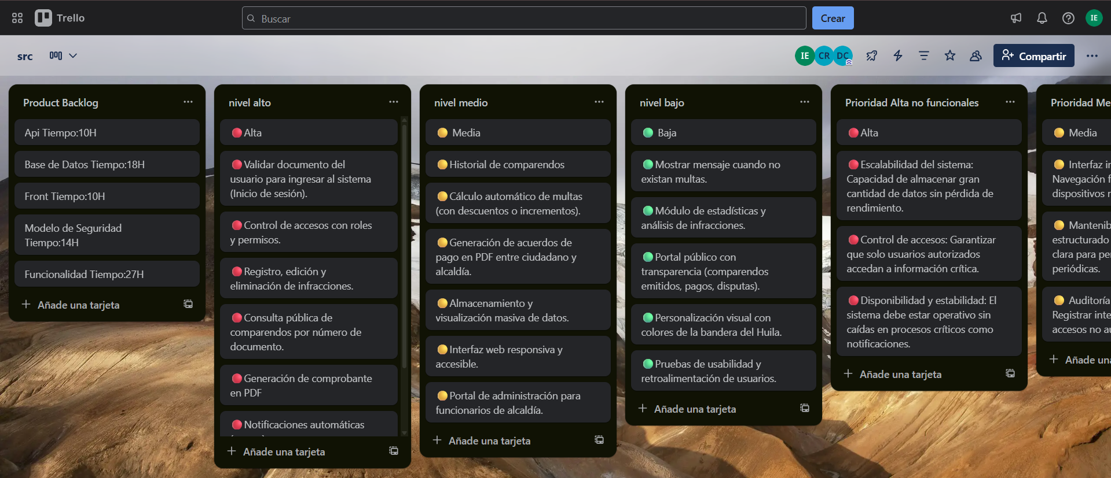  
  
  
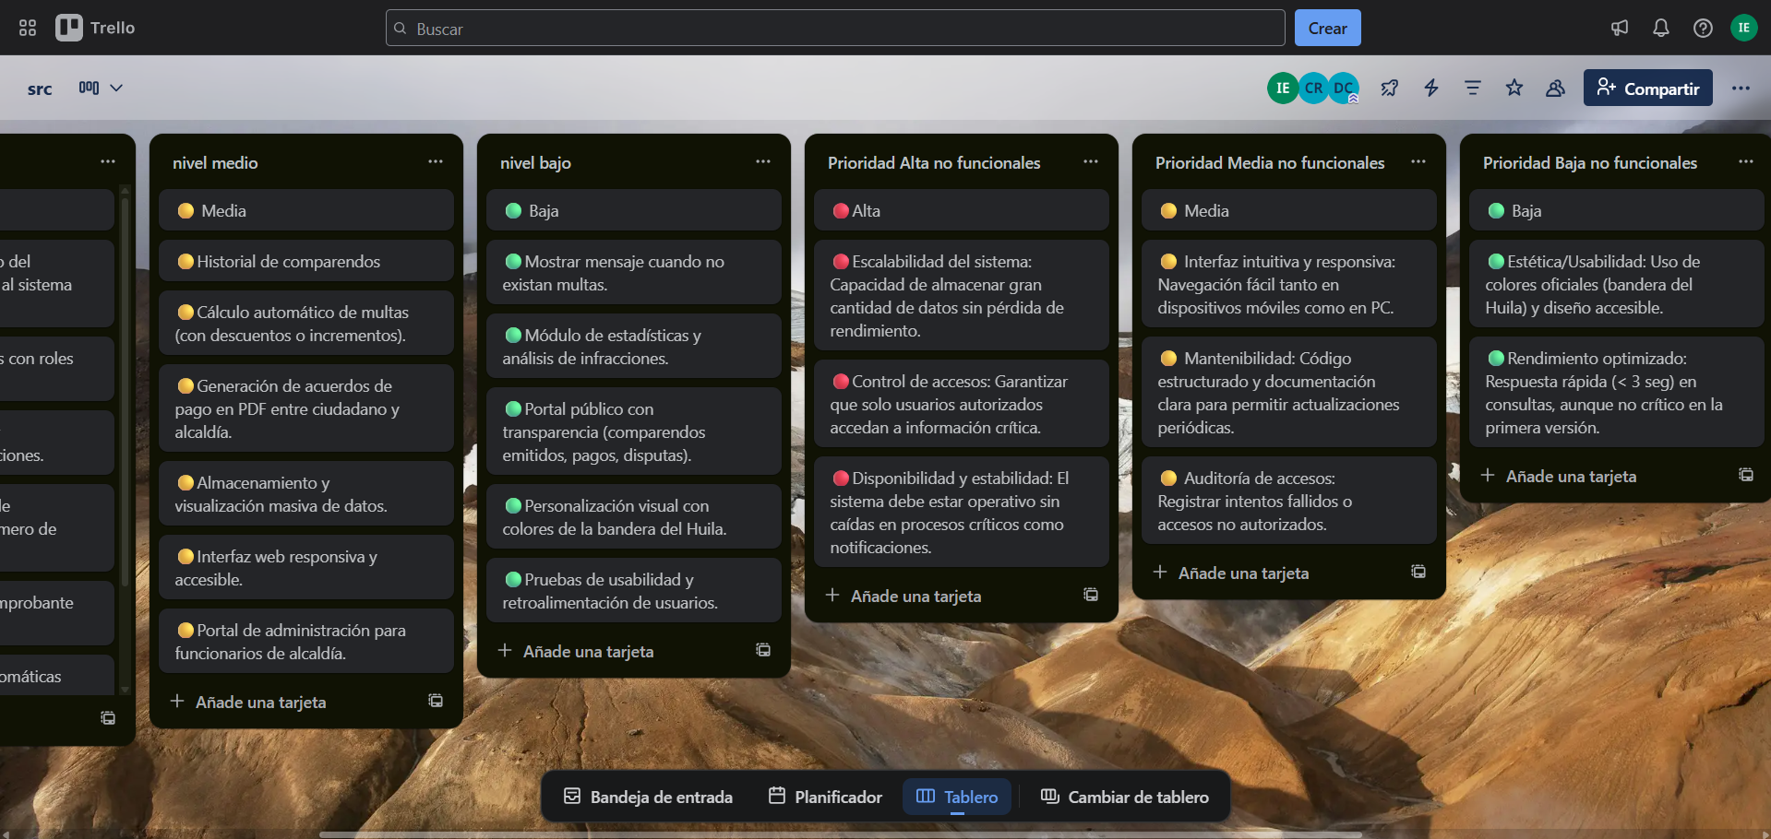  
  
<https://trello.com/invite/b/68ce160d9cba4557c00b8fdc/ATTI13b19e2c09c9eb74dc9bc7272f64879d76D4D852/src>